INDUSTRIAL SURVEYING

3

3

3

3

3

3

INDUSTRIAL SURVEYING

INDUSTRIAL SURVEYING

3

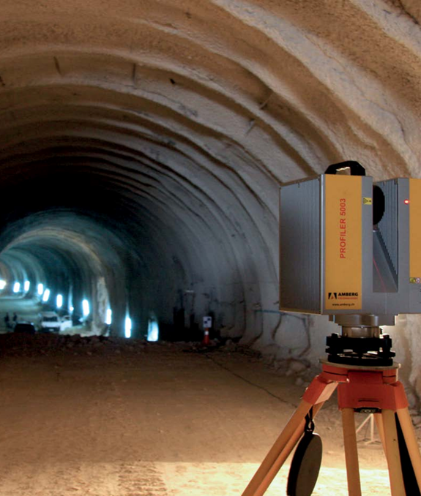

THE COMPANY

In today's complex construction environment our innovative expertise, analysis and carefully crafted approach can help bring security to construction process. AKSM implements high accuracy applications which allow us to obtain precious indications of the behavior of a structure and of the fields behaviors on which the site is situated.

By using high precision equipment, software and methodologies and especially with many years of experience in the field of laser scanning, the company can provide results, to meet the requirements of delicate projects

2

Surveying Precision

LASER SCANNING & BIM

3

‘Alexandros Karditsas & partners

Surveying Consulting Servises’│AKSM│

392 Mesogeion Avenue│15341 Agia Paraskevi, Athens│GREECE

T: +30 210 9702510│F: +30 213 0285617│M: +30 694 4774491

info@aksm.gr

www.aksm.gr

Laser Scanning & BIM

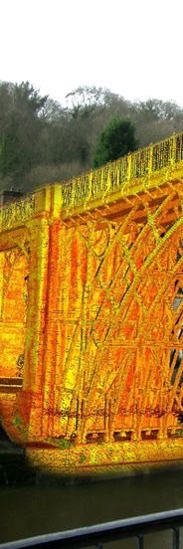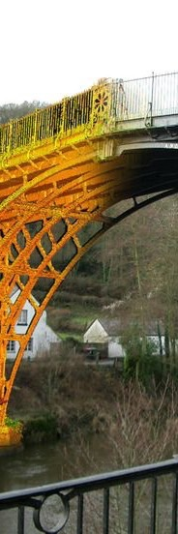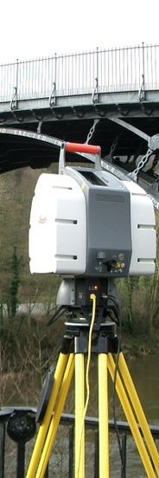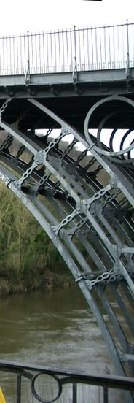

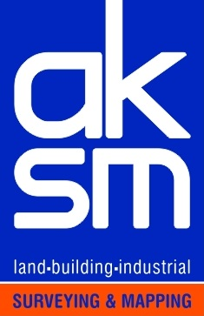

**SURVEYING PRECISION**

INDUSTRIAL SURVEYING

Surveying Precision

www.aksm.gr

Surveying Precision

INTUSTRIAL SURVEYING

www.aksm.gr

**COMPANY’ S PROJECTS**

* Emek S.A. – Halivourgiki SA – RM2 UNIT & SPOOLER UNIT IN HALIVOURGIKI PLANT

Extension of RM2 Unit and Construction of Spooler Unit in Halivourgiki Plant, Eleysina

Civil engineering in earthworks, foundations, underground networks, and substations of the No 2 grid building, rolling warehouse, new RM2 mill, new Spooler building and expansion of RM2 mill

* Emek S.A. – GAS COMPRESSION STATION

Erection of Gas Compression Station in New Messimvria, Thessaloniki.

* J/V Terna S.A., Salini Impregilo S.p.A. – SNFCC

Construction of Cultural Center – Stavros Niarxos Foundation, Athens

* EMEK S.A. – TSAKONA BRIDGE

Construction of Tsakona Bridge - Kalamata

* Intrakat S.A. – 5 NEW SILOS AT HALYPS CEMENT INDUSTRY

Construction of 5 new Silos in the area of Halyps Cement Industry in Aspropyrgos, Attiki

* Terna S.A. – UNIT V MEGALOPOLIS

Construction survey into the construction of Unit V – PPC Megalopolis

* Power Alstom Italia S.p.A. – UNIT III MEGALOPOLIS

Construction of WFGD Unit III at Megalopolis Site

* Emek S.A. – WIND TURBIN TOWERS

Manufacturing of Wind Turbine Towers at Emek S.A. Factory in Aspropyrgos, Attiki

* Emek S.A. – RIO – ANTIRIO BRIDGE

Replacement of Rio – Antirio Bridge special parts

Wind Turbine Towers at EMEK S.A Factory , Aspropyrgos.



5

High Pressure Natural Gas and Regulating Station, Tema, Ghana

4

INDUSTRIAL SURVEYING

INDUSTRIAL SURVEYING

**High accuracy applications**

**at Industrial surveying**

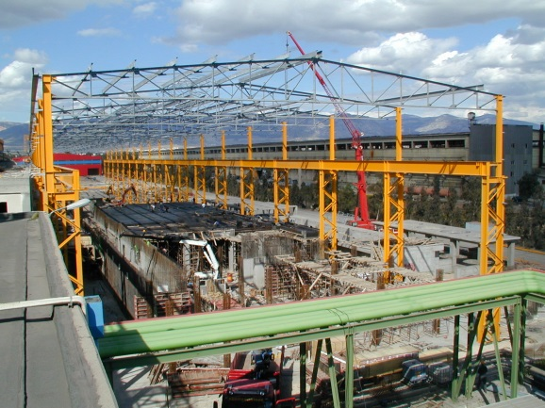

* As Build- Survey of Gas Compression Station at New Messimvria, Thessaloniki.
* Center Line verification and As Build- Survey at RM2 Unit at Halivourgiki plant.
* Geometry control of Wind Turbine Towers at EMEK S.A Factory during fabrication at Aspropyrgos.
* Alignment control of bridge crane rails at Corinth Pipeworks S.A at Thisvi, Voiwtia.
* Wet Flue – Gas Desulphurization (WFGD) Unit Filter Tower - Top Level Scan for piping adjustment at Unit III of Public Power Corporation S.A. (PPC S.A.) at Megalopolis.
* As –Build Survey of five newly constructed silos installation for raw materials and combustibles, installation with slipform technology at Halyps Cement – Italcementi Group Project at Aspropyrgos.
* Real Time Automated Monitoring System (AMS) - Deformation Monitoring of Wet Flue – Gas Desulphurization (WFGD) Unit during hydro testing at Unit III of Public Power Corporation S.A at Megalopolis.
* Deformation Monitoring of Trafigura Tank Farm at Tema , Ghana.
* Deformation monitoring of high pressure Natural Gas Metering & Regulating station to the Feeding of V.R.A at Takoradi, Ghana.
* Geometrical control for replacement of Rio – Antirio Bridge’s special parts, Bridges frame Center Line verification.

RM2 Unit at Halivourgiki Plant



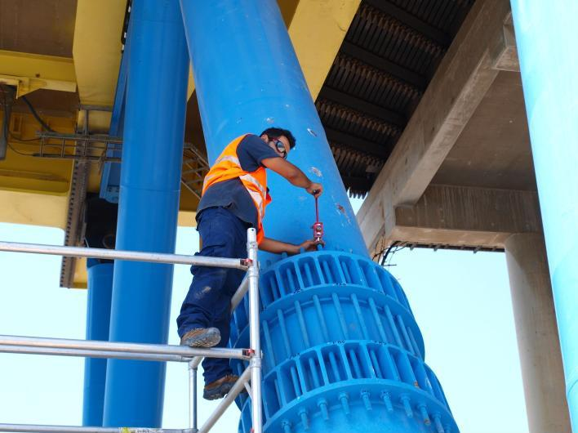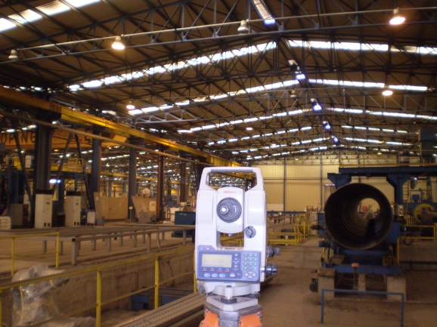

WFGT Unit at Unit III of PPC S.A, Megalopolis

Replacement of Rio – Antirio Bridge’s special parts

Bridge crane rails at Corinth Pipeworks S.A at Thisvi, Voiwtia.

Trafigura Tank Farm at Tema , Ghana.

6

7

Unit V of PPC S.A, Megalopolis

* Undertaking of the whole project organization.
* Participating in all stages of construction starting from the initial design until the final operation.
* Coordination of the designs studies.
* Offering expert consulting services throughout the project by incorporating special surveying applications into our services.
* Providing accurate and updated field data to all designers.
* Documentation of quantity surveys.

Company’s Aims

Provision of consistent and dependable quality services.

Project delivery on time and within budget.

Meeting the needs of our clients on project basis.

* Consulting on the financial, technical and operational requirements of each project.
* Working with the teams of the subconstractors.
* Management of info & data flow between all of the involved parties.
* Performing all surveying works according to ISO standards.

 ‘Alexandros Karditsas & partners Surveying Consulting Services’|AKSM│ 392 Mesogeion Avenue | 15341 Agia Paraskevi, Athens| GREECE |

SURVEYING PRECISION

www.aksm.gr

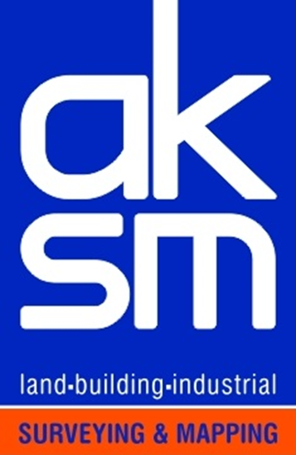T: +30 210 9702510| F: +30 213 0285617 | M: +30 694 4774491 | E-mail: info@aksm.gr